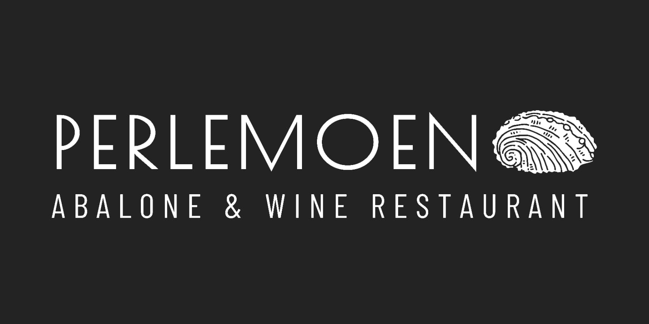

*Starters*

Pan-fried Abalone served with curried aioli R105

Fish Cakes with tartare R85

Abalone and Prawn half-Moons served with

Cucumber and fennel slaw R90

Beef Carpaccio R110

Patagonian Squid tubes with chimichurri dressing

and fragrant rice R120

Mussels cooked in a creamy white wine sauce R115

(Tomato based available)

Creamed Abalone with rice and crostini R120

*Mains*

Caesar Salad R90

Add Chicken or Avocado R30

Old Harbour Chowder (Line fish, haddock, mussels ) R120

Seafood orecchiette pasta R160

*Line fish, mussels, calamari, Prawns and Neapolitan sauce*

Pan-fried Hake with potato and green bean salad R120

Slow Roasted Pork Belly, creamy Samp, green beans

And caramelized onion Jus R185

Abalone Risotto R140

Fallafal

*Desserts*

Chocolate Ganache Tart R80

Tipsy Tart R75

Ice Cream Vanilla, Pistachio, Chocolate Brownie R35

Affogato – Vanilla Ice cream, espresso and choice of

Liquor. | Grappa | Amarula | Kahlua R75